 | Cheese Board: Cheddar Instructions
Date: | 24/09/17 | Version: | 1.0 | By: | Matt Little

This is an ESP8266 breakout board with small display, user inputs and WS2812 LEDs.
This is designed as a low cost platform to quickly get started with projects with the ESP8266. We wanted to design something that got you up and running with your project idea quickly and easily.
The main processor is based upon the ESP8266 system-on-chip from Espressif Systems.
This can be programmed via the Arduino IDE (or your favourite IDE).
This is a reasonably simple kit which requires some soldering.
It should take 1-2 hours to build.
Not suitable for under 12 years old.

Parts included:
 |  |  | Laser-cut Enclosure |  |  | 3 x AA rechargeable batteries
1W Solar PV Modules
1W Solar PV Modules |  |  |  |  |  |  |  | Battery Holder
DC-DC
Converter

DC-DC  Converter |  |  |  |  |  |  |  | 7 x M3 Hex spacers
PCB |  |  |  |  |  |  |  | 7 x M3 6mm  7 x M3 8mm
 |  |  |  |  |  |  |  | Sticky Pads
Wire
 |  | Diode 1N4001 |  |  |  | Switch + 2 x M2.5 screws

Enclosure Parts:
Top 1 |  | Front
Top 2
Top 3 |  | Back
Bottom 1
Bottom 1
Bottom 1 |  | Switch  Holder

Parts list:
Item | Ref | Quantity
Capacitors. 100nf  U1 NODEMCU  R1 330  SW1 ON/OFF  U2 74LVC1G17  PCB  NODE MCU 15 way connector  OLED 4 way connector  OLED Fittings  Enclosure | C1-5 | 5
Diode. 1N5819 | D1, D2 | 2
LED. WS2812. Pre soldered | D3-7 | 5
LED. Red. NOT included | B8 | Not Included
Display. OLED. 0.96" | DISP1 | 1
Encoder | ENC1 | 1
Fuse. 500MA | F1 | 1
NodeMCU
USB micro Socket. Pre-soldered | P1 | 1
2 way screw terminal. 5V | P2 | 1
HC-11 Serial. Optional | P3
Software Serial. Optional | P4
Node MCU header. 15 way. | P5, P6 | 2
PCB |  | 1
Switch |  | 1
M2 Machine screws 10m long |  | 2
M3 Machine screws 6mm long |  | 7
M3 Machine screws 8mm long |  | 7
M3 Threaded Hex spacers 8mm long |  | 7
3 x AA Battery Holder |  | 1
AA NiMH Rechargable Batteries |  | 3
1Wp Solar PV Units. 5V max out. |  | 2
Wire – Red and Black |  | length
Laser-cut enclosure (9 pieces) 3mm Ply |  | 1
Double sided sticky pads |  | 3

Tools required:

 | 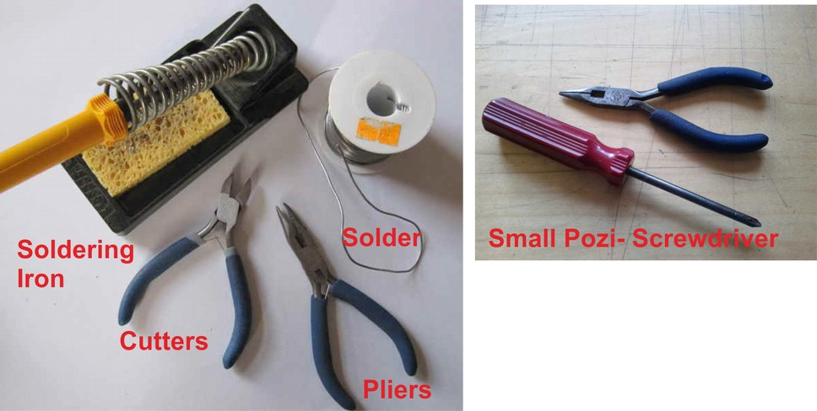
Long-nosed
Pliers
Soldering Iron |  | Posi-drive  Screwdriver
Solder
Side cutters

Instructions:
Step: 1 | Solder capacitors

Step: 2 | Solder diodes

Step: 3 | Solder switch

Step: 4 | Solder header pins
Step: 5 | Solder encoder

Step: 6 | Solder fuse

Step: 7 | Solder screw terminals (if needed)

Step: 8 | Fit LCD

Step: 9 | Add enclosure

Step: 10 | Build is finished!
Test with micro-USB cable.  Switch on and check LEDs light. |  | Have a nice cup of tea.  

Step: 11 | Upload software

Contact details:
This kit has been designed and produced by:

The Curious Electric Company
hello@curiouselectric.co.uk
www.curiouselectric.co.uk
Hopkinson Gallery, 21 Station Street, Nottingham, UK, NG2 3AJ

We would like you to be happy with this kit. If you are not happy for any reason then please contact us and we will help to sort it out.

Please email hello@curiouselectric.co.uk with any questions or comments.
Please tweet us at @curiouselectric

If any parts are missing from your kit then please email hello@curiouselectric.co.uk with details, including when and where the kit was purchased.

More technical information can be found via www.curiouselectric.co.uk

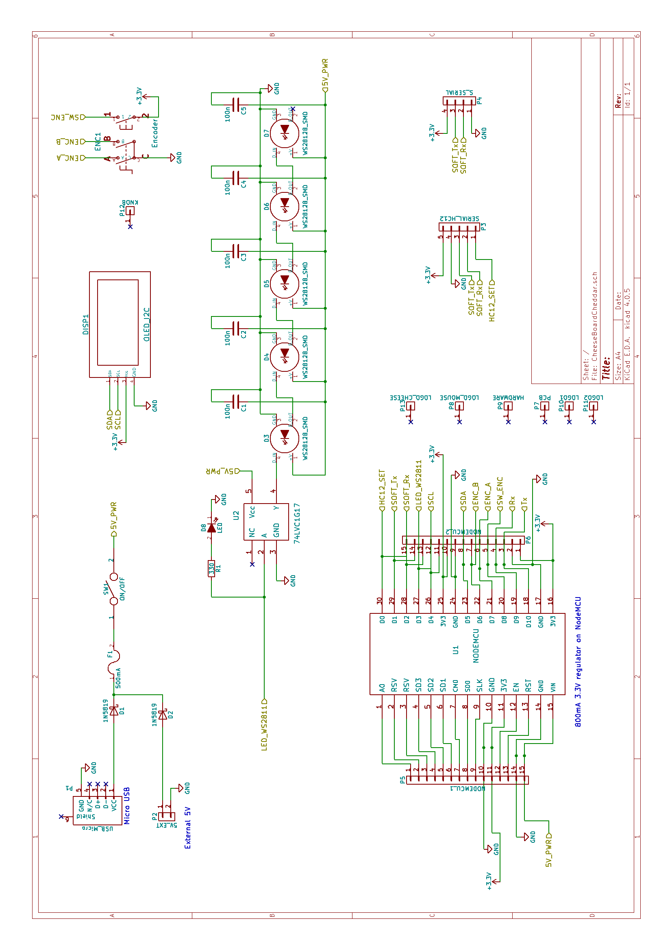
Circuit Schematic:

PCB Design:

Useful Information:
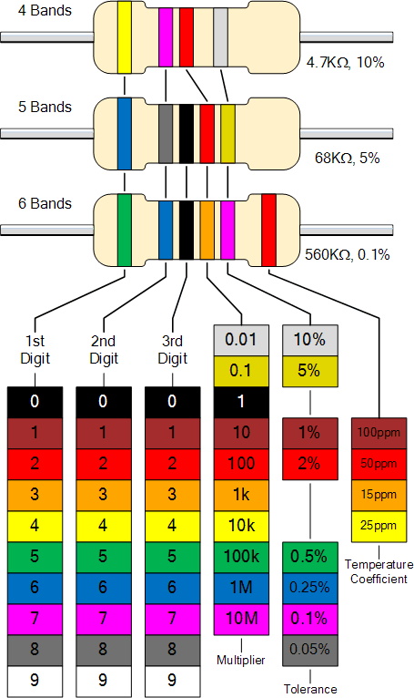
0

1

2

3

4

5

6

7

8

9

